FOR STUDENTS

click on Attendance
fig 1 Menubar

click on record Attendance
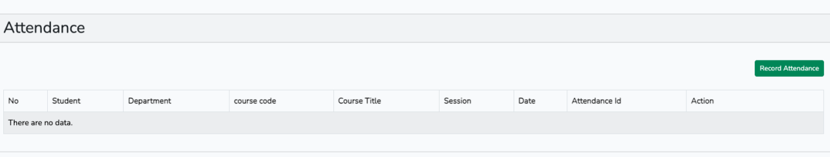
fig 2 Attendance home page

click on record Attendance
add the lecture id (the sixteen digit number) given to you by the lecturer and the number given to you when collecting attendance (tally number)
and click submit

PLEASE MAKE SURE YOU ARE SIGNED IN TO YOUR OWN ACCOUNT
