click on register

fig 1 landing page

fill all the fields and click register
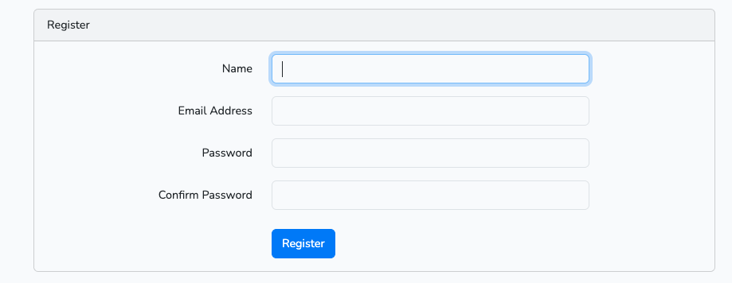
fig 2 Registration page

it will take you to this page where you will fill your profile information
please fill all the neccesory fields
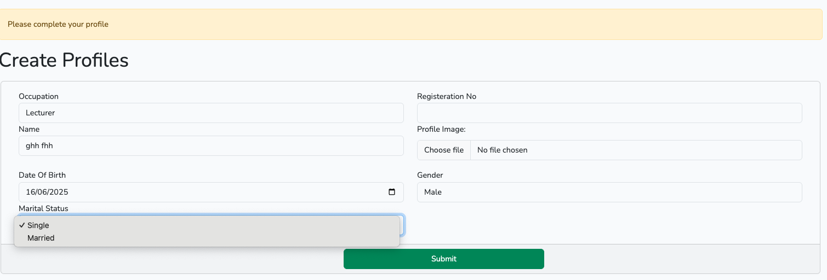
fig 3 Profile form

it will take you to this page where you will continue your profile information click on edit profile

fig 4 personal information page
it will take you to this page where you will continue your profile information click update
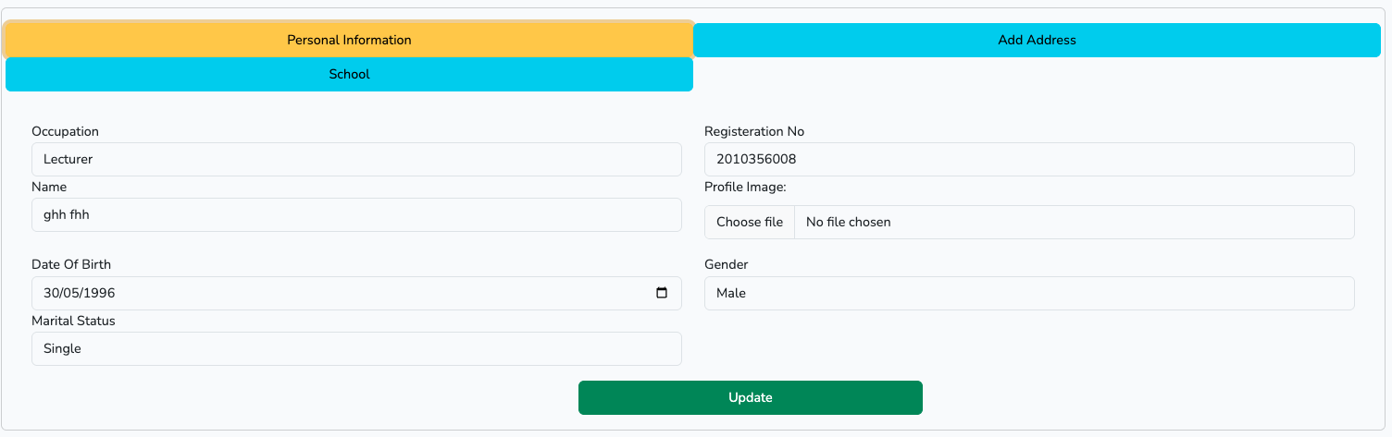
fig 5 Profile continue

it will take you to this page where you will continue your Address information click update
if the already selected state or LGA is not for you start by reselecting the Nationality then select state and then select LGA
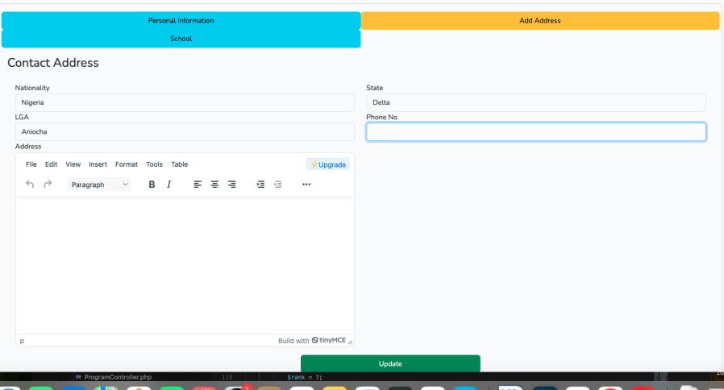

fig 5 Profile continue

It will take you to this page where you will continue your School information click update
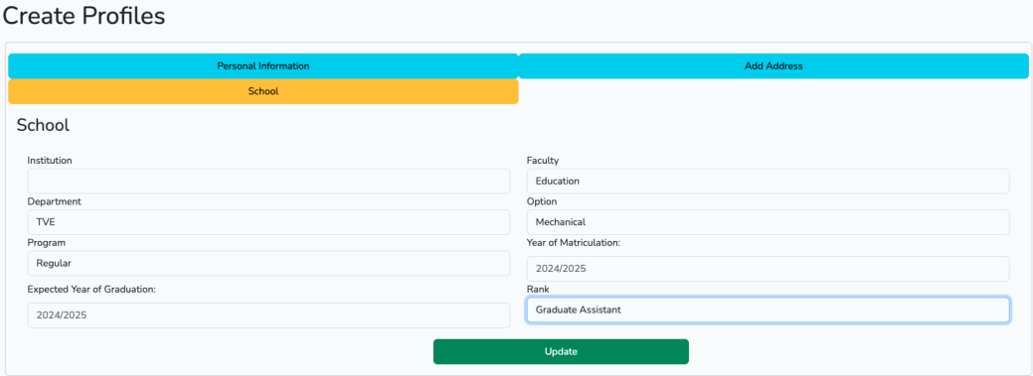
fig 6 Profile continue

NEXT OF KIN INFORMATION
click on the “click to add Next of Kin button
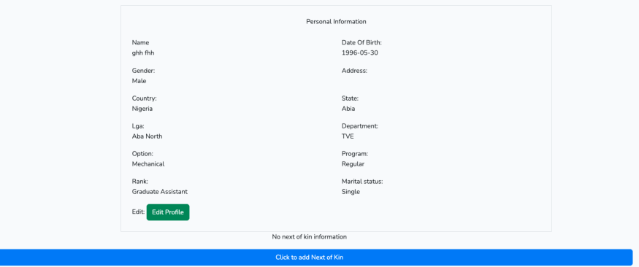
fig 7 profile information

file all the fields and click submit
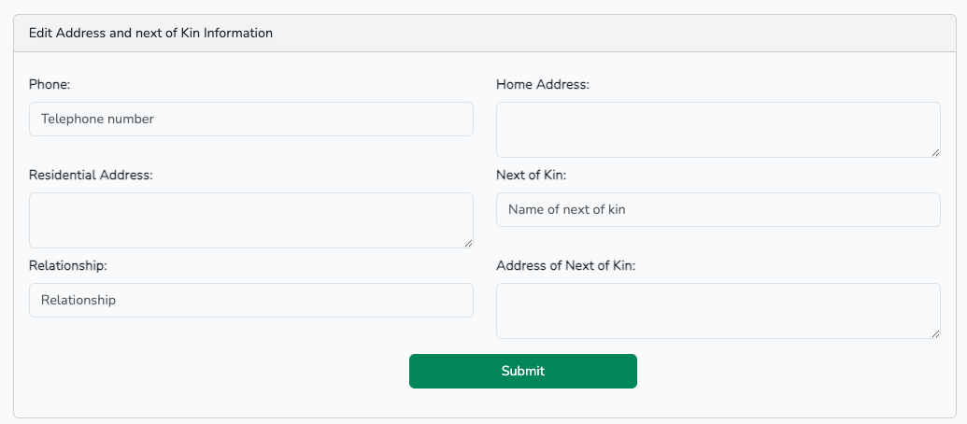
fig 8 next of kin information form

